

Anthony Halberstadt
Indiana Society Chapter
Rev 1
Chapter Officer Duties V6

Table of Contents
Mission Statement and Goals 2
Chapter History 3
Introduction 5
President 6
Vice President 8
Secretary 10
Assistant Secretary / Webmaster 11
Treasurer 13
Registrar 15
Genealogist 17
Historian 19
Chaplain 20
Sergeant-At-Arms 21

Mission Statement and Goals

The Mission Statement of the SAR:
The Sons of the American Revolution honors our Revolutionary War patriot ancestors by promoting patriotism, serving our communities, and educating and inspiring future generations about the founding principles of our Country.

Goals of the SAR:
Patriotic, Historical, and Educational.

Chapter History

- The Anthony Halberstadt Chapter of the Sons of the American Revolution was named after Hessian solder, Anthony Halberstadt, who was captured at Trenton, by General George Washington on December 26, 1776. Anthony Halberstadt later became a driver for one of the Generals in the Continental Army.
- James Franklin Halberstadt, founder of chapter, was born in 1912 and passed in 1983. He was the 3rd great-grandson of Anthony Halberstadt.
- James Halberstadt was born in Pleasant Mills, Indiana. He played baseball (catcher) on his High School team, and later pitched horseshoes at the county and state level. He won the individual horseshoe runner-up at the State in 1952.
- Jim worked at Harvester in Fort Wayne, served for three years in the Army in the Pacific Theatre of Operations, and worked multiple types of job when he moved to Decatur in 1952.
- Jim fought multiple diseases in his life: polio, a fractured skull, hepatitis, bladder cancer, and a muscle disease that attacked the use of his legs.
- Jim founded the Anthony Halberstadt Chapter on July 19, 1969. He called the meeting to order using a gavel made from the home of William Henry Harrison in Vincennes. The first officers were:
  - President: Jim Halberstadt
  - Vice-President: Don Melching
  - Secretary: Dick Heller Jr.
  - Treasurer: Douglas Halberstadt.
- Other founding members were James F. Halberstadt Sr., James Jerome Yager, Alonzo F. Halberstadt, L. Luther Yager, Melvin Werling, and Lester Halberstadt.
- James Halberstadt founded the local Children of the American Revolution (CAR) on October 25, 1969.
- The Anthony Halberstadt Constitution and Bylaws were adopted on June 14, 1970.
- The Antony Halberstadt Chapter hosted the Indiana State Society on October 7, 1974.
- James Halberstadt was awarded the Indiana State Society Good Citizenship Medal on July 13, 1970.
- Jim Halberstadt organized the Morgan Raid Camp Chapter of the Sons of Union Veterans, was commander for the Disable American Veterans, a member of the Descendants of Colonial Clergy, and Society of Colonial Wars, among many others.

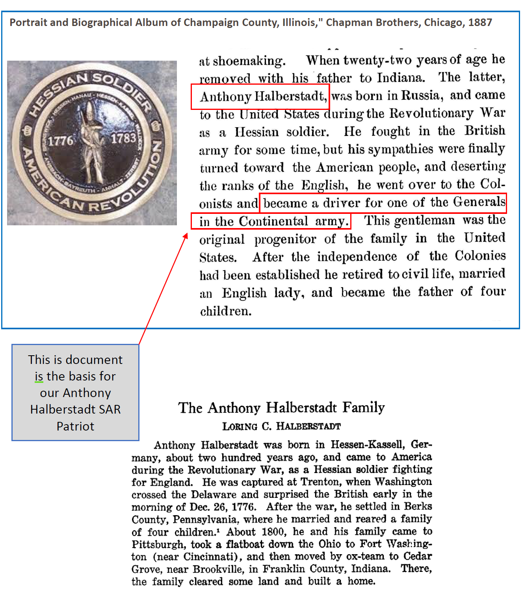

Introduction

The defining documents of the Anthony Halberstadt Chapter are our Constitution and By-Laws. These are maintained by the Chapter Secretary and published to the Chapter Website.
The Constitution establishes the Chapter Officers in Article IV (Officers) Section 1: The officers of this Chapter shall be; a President, a Vice President, a Secretary, an Assistant Secretary/ Webmaster, a Treasurer, a Registrar, a Historian, a Chaplain, and a Sergeant-at-Arms.
Article IV Section 2 establishes the Executive Committee: The administrative affairs of this Chapter shall, except as may be otherwise provided by the By-Laws, be under the supervision of an Executive Committee which shall consist of the elected officers.
Article IV Section 3 establishes the term of office: All officers shall be elected at the last regular meeting of the year, and they shall hold office for two (2) years and until their successors are duly installed. Any officer may be removed from office for inefficiency by two-thirds' vote of the Executive Committee, and by two-thirds' vote of the Chapter members attending the next regular meeting.
The By-Laws enumerate the Officer duties and are found in the succeeding sections.

President

By-Law Article II, Section 2: The duties of the President shall be to preside at all meetings and to have a casting vote. He shall exercise the usual functions of the office and shall enforce strict observance of the Constitution and By-Laws of the Chapter. He shall endeavor to establish and maintain a program of activities which will be of interest to the membership.
The President is the chapter’s Chief Executive Officer and is charged with the management of the entire chapter.
Duties:
- Establishes and monitors the goals of the Chapter.
- Maintains general supervision over the Chapter and ensures the chapter operates within the Bylaws. Oversees that all current officers are performing their duties and responsibilities. Establishes training for new officers.
- Conducts periodic and planned chapter meetings (Quarterly). Sets an agenda and runs the Chapter meetings. Invites applicants and prospective members to Chapter meetings.
- Assigns committee members and appoints committee chairmen. Develops new committees, as needed.
- Oversees the Chapter’s budgetary and financial activities. Assigns an Ad Hoc Committee to conduct a financial review of the Treasurer’s books annually. Ensures the timely annual filing of the IRS 990-N form.
- Calls Officer elections per the Bylaws. Requests State President or District VP to install new officers.
- Ensure chapter meetings are well planned and there is an agenda for each meeting. Notifies members in advance of upcoming meetings and events.
- Directs the recruitment of new members and retention of current members.
  - Sets recruiting goals for the year.
  - Coordinates with local DAR chapter(s) for male relatives as potential applicants.
  - Encourages recruiting through membership booths at commercial venues, post membership notices at libraries, polls chapter member for family members, and coordinates the public use of speakers.
  - Notifies new members of their approval and inducts them into the SAR.
  - Ensures new members receive indoctrination training and are assigned a Mentor.
  - Oversees the retention efforts of current members through surveys, interviews, and engagement.
- Actively plans and oversees all chapter sponsored events ensuring compliance with NSSAR protocols.
- Establishes and maintains a Chapter Color Guard and actively participates.
- Sponsors youth events, flag presentations and certificates, participation in veteran’s affairs, participation in community and patriot events. Issues proclamations to recognize noteworthy achievements and events.
- Coordinates rewards with the Chapter VP for deserving and worthy members of the community and the chapter.
- Ensures the timely and accurate submission of required reports:
  - Quarterly District VP Report
  - Annual Reconciliation Report (input on member dues payment)
  - Americanism, Flag, and USS Stark Memorial Reports
  - Death of a Compatriot Report
- Attends the three (3) State meetings during a calendar year (or ensures a Chapter Officer is represented).

Vice President

By-Law Article II, Section 3: The duties of the Vice President shall be to preside at meetings in the absence of the President. He shall assume and discharge such duties as may be delegated by the President.
The Vice President is the chapter’s future successor to the President and is charged with fulfilling duties assigned by the President, and those assigned to the President, as necessary.
Duties:
- Presides over the chapter in the absence of the President.
- Assists the President in carrying out his duties.
- Learn and engage with key chapter operations in preparation for becoming president, which may include:
    - Overseeing, monitoring, and coordinating the progress of the chapter’s committees. Assures the committees are working together in harmony to achieve the chapter’s goals.
    - Assisting or leading the chapter’s leadership development.
    - Assisting or leading the chapter’s membership recruitment, retention, and reinstatement activities.
    - Assisting with chapter communications, specifically social media.
    - Event and venue planning.
    - Other important special projects or activities as needed.
- Assists in the planning, location selection, and agenda of chapter meetings and events.
- Administers the training program for members.
- Conducts SAR fundamentals training of new members, issues New Member Guidebook, and assigns a Mentor.
- Conducts the training of Mentors and Chapter Officers
- Manages the Retention efforts of current members through surveys, interviews, and engagement.
- Chairs the Program Committee (i.e., lines up the speaker for chapter meetings).
- Chairs the Awards, Planning & Budget, and Membership Committees.
- Prepares recognition certificates. Issues medals and awards.

Secretary

By-Law Article II, Section 4: The duties of the Secretary shall be to keep fair and accurate records of all the proceedings and orders; and shall give notice to the several officers of all votes, orders, resolves and proceedings of the Chapter and Society affecting them or appertaining to their respective duties. He shall give due notice of the time and place of all meetings. He shall conduct the general correspondence under the direction of the President. The Chapter Secretary, immediately after election, shall notify the State Society and the National Society of the names and addresses of the newly-elected officers.
The Secretary is the chapter’s Chief Administration Officer and receives and acknowledges correspondences, keeps an accurate written record of the proceedings of all meetings, communicates appropriate information to officers and all members, order supplies, and maintains important files for the chapter.
Duties:
- Conducts general correspondence of the chapter.
- Maintains the official records of the activities of the Executive Committee, and Chapter meetings.
- Coordinates with the chapter leadership on compiling the officer and committee reports for distribution at meetings.
- Ensures quarterly Chapter meeting notices are issued by email or written notification and also oversees any meeting registrations.
- Receives approved new membership and supplemental packets and notifies the Chapter Registrar, Chapter Genealogist, and Chapter President.
- Maintains the current copy of the Chapter bylaws and other Chapter documents.
- Attends meetings of the Chapter membership and executive committee; records and publishes minutes of these meetings.
- Assists the President in preparing Chapter and Annual meeting reports to the State Secretary or District VP.

Assistant Secretary / Webmaster

By-Law Article II, Section 4: The primary duty of the Assistant Secretary / Webmaster shall be to develop, support and maintain the Chapter’s website and social media platforms. The Assistant Secretary may also be asked to fulfill the duties of the office of the Secretary in the event of his absence, incapacity, death or resignation.
The Assistant Secretary / Webmaster is the chapter’s Chief Deputy Administration Officer and oversees the chapter’s website.
Duties:
- Assists the Chapter secretary, as needed in the performance of his duties, primarily in the areas of configurations, meetings, and communications.
- If requested by the Chapter secretary, the assistant secretary may perform the following configuration duties:
  - Create, publish, and archive the Chapter Constitution and Bylaws.
  - Create, publish, and archive the Chapter Officers and Committee Points of Contact.
  - Submit and archive the Chapter Tax Reporting Forms.
- If requested by the Chapter secretary, the assistant secretary may perform the following meeting duties:
  - Announce and distribute quarterly Chapter meeting notices.
  - Announce and distribute Chapter Executive Committee meeting notices.
  - Create, publish, and archive Chapter meeting minutes.
- If requested by the Chapter secretary, the assistant secretary may perform the following communication duties:
  - Request, consolidate, and publish quarterly input to the State Hoosier Patriot.
  - Request, consolidate, and publish quarterly input to the National SAR Magazine.
- Posts Chapter updates, news articles, pictures, and events to the Chapter website.
- Submits the Chapter website as a candidate for the annual National SAR website competition.

Treasurer

By-Law Article II, Section 5: The duties of the Treasurer shall be to collect and keep funds of the Chapter and deposit same in a bank or savings institution designated by the officers. He shall draw on the funds for the payment of such obligations as may be approved by the officers or membership. He shall keep a true account of his receipts and disbursements and make a report thereof from time to time and submit an annual account at each annual meeting.
The Treasurer is the chapter’s Chief Financial Officer and oversees the administrative transactions and investments of the chapter. He makes sure that the organization understands its financial obligations and makes sure the organization is compliant with its filing responsibilities.
Duties:
- Chairs the Finance Committee.
- Keeps accurate accounts of receipts and expenditures.
- Collects and records money received from members, individuals or organizations providing donations or for grave markings.
- Keeps an accurate list of all monies deposited to the Chapter account and allows the Chapter Audit Committee to examine the Chapter accounts a minimum of once a year.
- Maintains a finance system that is capable of:
- Receiving and securing income.
- Dispersing funds to pay expenses.
- Reporting on the financial status of the chapter.
- Maintains a current accounting of all monies belonging to the Chapter; reports to the Secretary at each meeting and to the membership as requested by the President.
- Pays all expenses authorized by the President, per the approved budget, and/or voted on by the members.
- Works with the chapter Registrar to collect and submit national and state member dues to the state Registrar.
- Prepares an end-of-the year financial report for the year ending March 31st and submits to the State Secretary in April of each year.
- Annually submits the IRS 990 N form to maintain the chapter’s nonprofit status.
- Provides charitable donation notifications to individuals that donate to the Chapter.

Registrar

By-Law Article II, Section 6: The duties of the Registrar shall be to keep a roll of the members and shall examine and approve, or disapprove, applications for membership.
The Registrar oversees the registration of new members of the Chapter. He maintains the Chapter membership records and assists in processing reinstatements, transfers, life memberships, memorial memberships, and deaths.
Duties:
- The Registrar shall be the custodian of the membership data of the Chapter.
- Maintains a current Chapter roster and records new members as necessary.
- Advises an applicant when he is approved for membership in the Society.
- Updates the National SAR Members Data System with member addresses, phone numbers, and email addresses.
- Coordinates with the Chapter Genealogist for submission of new and supplemental application packages to the State Registrar.
- Ensure in-process membership data is provided to the Chapter Secretary.
- Notifies the State Registrar of the death, resignation, or removal of any member, and also the change of officers. The “Change of Officers” form is provided to both the State and National Registrar.
- Submits National SAR death notices with the State Registrar and State Chaplain as necessary and updates the Chapter roster.
- Processes member transactions such as transfers, reinstatements, life member applications, etc. and updates the Chapter Roster.
- Ensures the State Registrar has the correct dues collection address of the Chapter Registrar for annual dues notices.
- Compiles annual dues notices in September for Chapter members and mails to the membership by October 1st.
- Works with the Treasurer on the completion and submittal of the Annual Reconciliation Report.

Genealogist

Special Appointment by Chapter President: The duties of the Genealogist shall examine and approve, or disapprove, applications for membership.
The Genealogist is the chapter’s Chief Genealogist. He is responsible for assisting applicants prepare and submit applications for membership, assisting members with supplemental applications, and for assisting prospective and existing members with research and documentation of lineage.
Duties:
- Keeps familiarity with the current National Genealogy Policy Manual and Application Processing Manual.
- Quickly responds to incoming contacts and inquiries from potential members. Reviews suggested contacts received from the State SAR website or State Genealogist for Chapter applicability.
- Performs genealogical research to assist potential applicants in determining their eligibility.
- Conducts periodic genealogical workshops to assist potential community applicants.
- Assists in the preparation of new applications.
- Generates an introductory letter or holds conversations to guide new applicants in starting their online application, and to set expectations.
- Examines all applications for membership using standards and guidelines established by the National Society, ensuring that all information is entered correctly, and that all documentation listed is eligible, legible, and included with the application.
- Encourages applications from other family members and guides them to apply under the existing family plan.
- Completes the application for the applicant to reduce errors and rejections.
- Compiles application packages and documents, and verifies correctness, along with the submission of applicable fees; then coordinates the final package with the State Genealogist.
- Performs similar actions when assisting with supplemental and memorial applications.
- Coordinates with the Chapter Registrar for package submission to the State Genealogist for passage to the State Registrar.

Historian

By-Law Article II, Section 7: The duties of the Historian shall be to keep the records of the historical and commemorative meetings, and he shall supervise the preparation and printing of its historical publications.
The Historian is the chapter’s Chief Historian and responsible for maintaining the Chapters historic files.
Duties:
- Maintains the Chapter history and collects newspaper clippings, photographs, etc. for use in maintaining the Chapter Scrapbook.
- Coordinates with the Chapter Chaplain and Chapter Secretary on recording the biographies (and submittal of the Obituary forms) on deceased Chapter members.
- Prepares and sends Chapter news to the Editor of the Indiana Patriot and the editor of the SAR Magazine as appropriate.
- Records all significant events / activities of the Chapter each year. Items to include and maintain in the chapter archives are:
  - Chapter Year Books, Newsletters, Photo Albums, Event Programs and News Clippings.
  - Records of patriot and compatriot burials in the chapter’s geographical area.
  - Previous chapter rosters and officer records.
  - Chapter Minutes and Annual Reports.
- Creates a Chapter Annual report (1 – 2 pages) containing selected historical events and submits it to the Indiana State Historian by April 1st each year. Example events are:
  - Change of Chapter Officers.
  - Grave Markings.
  - Color Guard activities.
  - Chapter and Individual awards
  - Volunteer activities.

Chaplain

By-Law Article II, Section 8: The duties of the Chaplain shall be to attend meetings and to pronounce the invocation and benediction and endeavor to give spiritual guidance to the membership.
The Chaplain is the chapter’s Chief Prayer Leader and carries out his duties during each of the chapter’s events.
Duties:
- Performs the Invocation and Benediction for each Chapter Meeting as called for by the Chapter President.
- Leads Compatriots in prayers at other SAR events such as Grave Markings, Memorial Events, Historical Commemorations and National Holidays.
- Communicates, whenever possible, with members who are ill or in distress.
- Consults with family and clergy concerning funerals and memorial services for deceased Compatriots.
- Coordinates the obituary reporting with the Chapter Secretary and maintains a current list of members who have passed away during the membership year.
- Provides a list of yearly deceased members to the Indiana SAR State Chaplain no later than March 15.
- Sends a sympathy card or condolence letter to the family of a deceased member on behalf of the President.

Sergeant-At-Arms

By-Law Article II, Section 9: The duties of the Sergeant-at-Arms shall be to preserve order at all meetings, and to perform such other duties as may be assigned to him by the President.
The Sergeant-At-Arms is the chapter’s Chief Enforcement and Protocol Officer and enforces all rules of the Chapter. He guards against the loss of our greatest possession—our deep and abiding spirit of comradeship.
Duties:
- Maintains a physical copy of the Chapter Charter issued by the Indiana State Society and has it available for the Chapter when needed.
- Maintains custody of Chapter property including all National, State, and Organizational Colors.
- Acts as the Color Guard Commander.
- Ensures all flags and signs are properly displayed at all regular and special meetings of the Chapter.
- Ensures all meeting rooms are properly prepared for chapter business.
- Supports the President by making sure all needed materials are present before the meeting.
- Provides motivation and enthusiasm to members and new guests. Arrives early to various functions and greets everyone who comes to each event.
- Ensures all Bylaws and traditions are respected by each Compatriot and visitor to Chapter events.
- Reports any infractions or violations of the chapter policies to the Chapter Executive Committee for further action.
- Acts as parliamentarian if one is not appointed, and ensures proper parliamentary procedures are followed during Chapter meetings.
- Calls Chapter meetings to-order and adjourns all meetings.

